**Name: Shweta JAmdar**

**Rollno: TEAD-22521**

**DS (SL-III)**

**Practical 12**

**Problem Statement: Write a simple program in SCALA using Apache Spark framework**

**Code:**

**Install Java:**

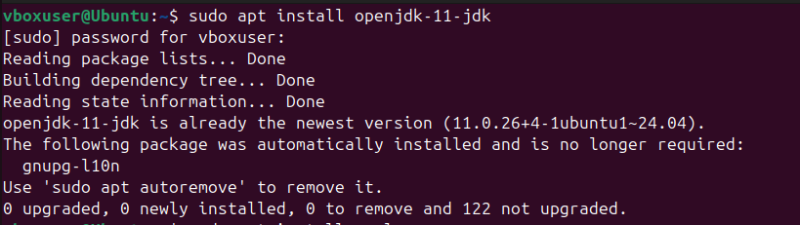

**Install Scala:**

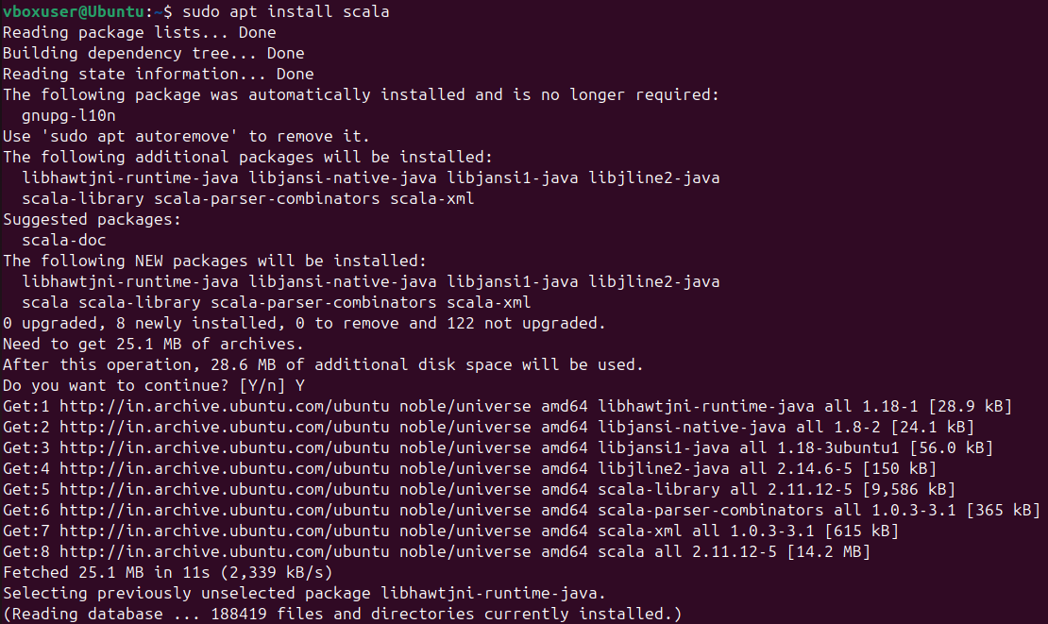

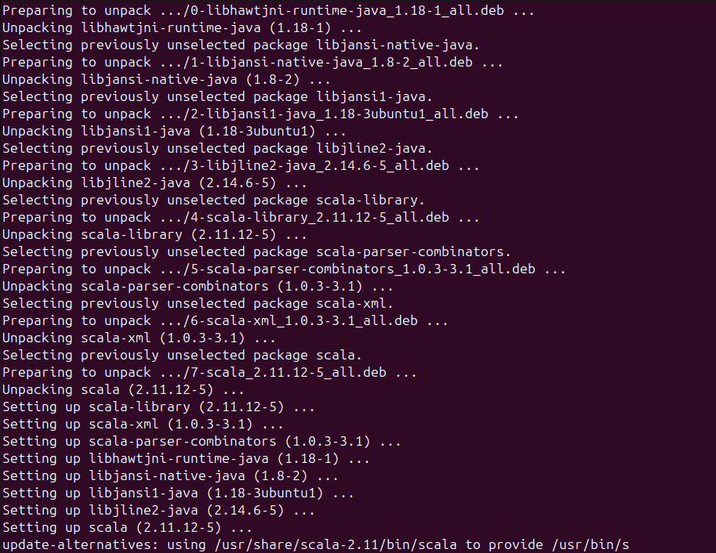

**Create a .scala file and write the code:**

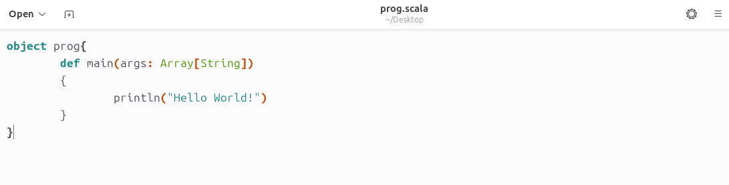

**Compile the prog.scala file in terminal:**

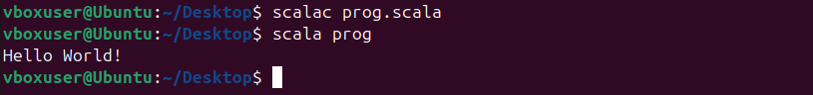

**After compiling, you will get prog.class as an output in the same directory:**

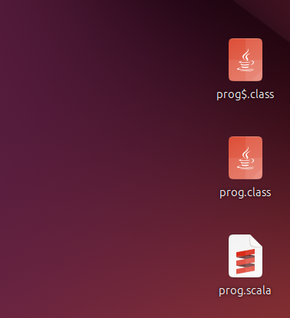

**Run the program using following command:**

